Planting and Planning: Warm Season Crops to Plant Now
Memorial Day has come and gone, and in Pittsburgh, that means that we are in the “safe” zone for planting warm season crops. For a full list of crops that like to grow in the summer, check out our previous Urban Harvester post that includes a seasonal planting chart. Here are some of our warm season favorites (all photos from Johnny's Selected Seeds):

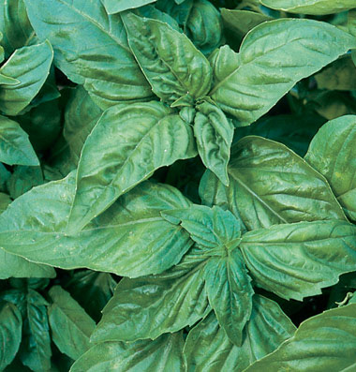
Large Leaf Italian Basil

Basil: Direct seed this aromatic herb, or plant seedlings for a faster crop. To harvest, trim the central stem right above a set of leaves; this method will encourage the plant to grow fuller. Select traditional Italian varieties like Genovese or Italian Large Leaf, or try a unique variety like Thai, lemon, lime, or Red Rubin.

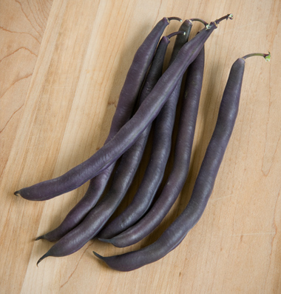
Royal Burgundy Beans

Beans: This legume grows best when it’s direct seeded. Choose from bush varieties or types that like to climb poles. There are traditional green, Romano, yellow, purple, lima, and shell beans in bush and pole options. As a bonus, bean seeds are easy to save and plant next year, as long as your variety is not a hybrid.

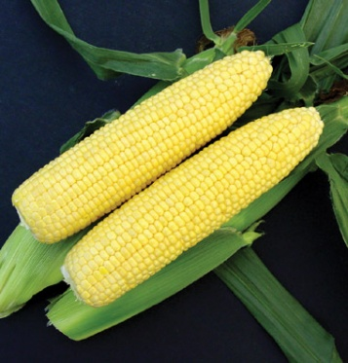
Vision Sweet Corn

Corn: Don’t plant corn unless you’ve got room for at least four rows, right next to each other. Corn wind-pollinates. To get ears full of kernels, you’ll need plenty of corn growing close together. The goal is for the pollen from the tassels to pollinate each individual corn silk, which creates one plump kernel of corn!

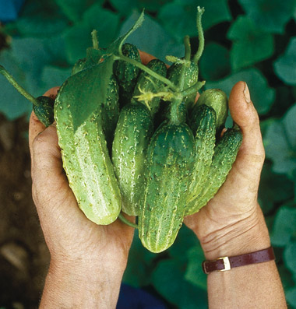
Northern Pickling Cucumbers

Cucumbers: These trailing plants grow well from seed. Make sure you plant them according to the seed packet’s instructions, so each plant has the space it needs. To protect them from cucumber beetles, which carry bacterial wilt, cover the plants with fabric row cover (no need for wire hoops) until the plants bloom. Choose from pickling or slicing types. For a real treat, try a thin-skinned seedless variety.

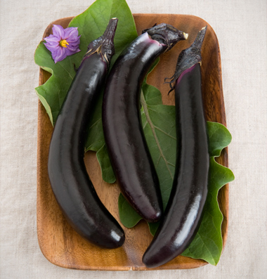
Orient Express Eggplant

Eggplant: These plants, in the same family as tomatoes, potatoes, and peppers, grow best from seedlings. Choose large Italian varieties, or small, quick-growing Asian types. The smaller the eggplant, the more tender it will be. No matter what variety you choose, pick the fruit when it is the expected size and still shiny.

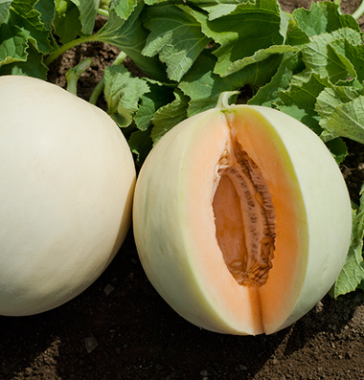
Honey Orange Melon

Melons: These tasty fruits grow easily from seed, as long as the soil is very warm. Check the days to maturity on the seed packet to make sure the Pittsburgh summer will be long enough to ripen the fruit. Try a traditional variety or a smaller, more refrigerator-friendly type. Both cantaloupes and melons will grow well in a hot Pittsburgh summer.

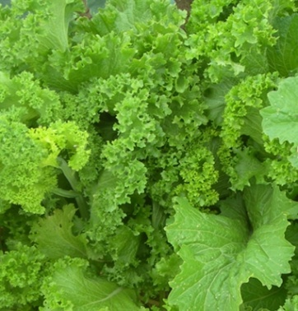
Southern Giant Curled Mustard

Mustard Greens: These plants love the heat. They grow well from seed – for a continuous supply, seed every couple of weeks throughout the summer. A drawback is their attractiveness to flea beetles. For a less holey crop, cover immediately after seeding with well-secured row cover.

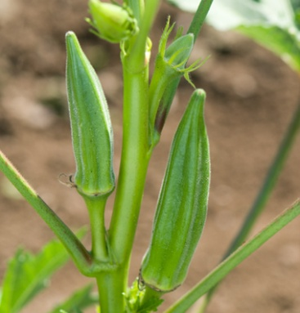
Jambalaya Okra

Okra: This heat-loving Southern crop can grow well in Pittsburgh if the summer weather conditions are right. The tall plants are in the hibiscus family and have beautiful flowers as a bonus to the edible okra pods! Plant from seed, and pick a quick-maturing variety for the best chance of success.

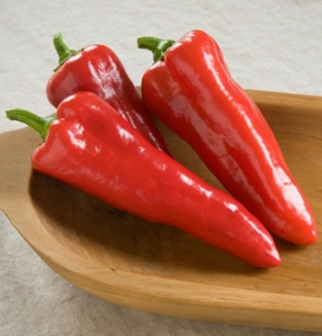
Carmen Sweet Peppers

Peppers: Sweet or hot, now’s the time to get these seedlings in the ground, if they’re not there already. If your seedlings already have blossoms when you plant them, pinch off the blooms, to encourage the plant to produce more fruit over the long run. Separate hot and sweet peppers in the garden, as they can cross pollinate and produce some spicy surprises on sweet pepper plants!

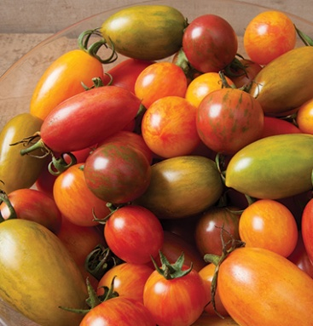
Johnny's Seeds' Artisan Tomato Collection

Tomatoes: Like peppers, these plants should go in the ground asap, if they’re not already planted. Choose indeterminate plants, which will need to be staked and tied up throughout the season, or determinate ones, which grow to several feet high, then stop. The colors and types are infinite – plant a few favorites and an experimental variety, if you have room.

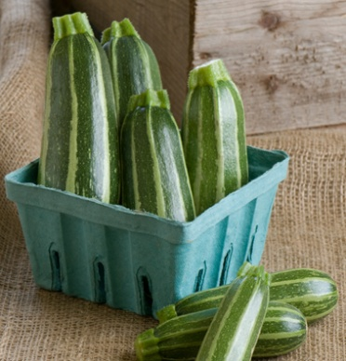
Bush Baby Zucchini

Zucchini/Summer Squash: These bushy plants love heat and they grow well from seed. There are beautiful yellow, white, and green varieties – choose from lots of shapes and sizes, too. For easier picking, try a spineless variety.
You can also seed carrots and beets throughout the summer months and into early fall. Happy planting!

