

**Garden Tips: First Crops to Seed Outdoors**

The weather is not making it easy to think spring, but believe it or not, warm days will be here soon! Traditionally, many gardeners plant peas on St. Patrick’s Day. However, if you haven’t already gotten your peas – or other spring crops – in the ground, rest assured that there is still plenty of time. Spring crops planted slightly later often catch up to earlier-planted ones, as they grow more rapidly due to the warming weather and longer days.

In the farming world, planting seeds directly in the ground is called *direct seeding*. This term differentiates seeding in the ground from planting seeds in the greenhouse – or in your home, in order to grow seedlings for *transplanting.* Some spring crops, like broccoli, cabbage, and cauliflower, grow best if they are transplanted. For more info on when to start these seeds inside, check out this [chart](http://www.johnnyseeds.com/e-PDGSeedStart.aspx?source=H_SSCalc_032013_rnavimg), and plug in the spring frost free date of May 15. You’ll notice several other spring crops on that list – many crops can be either direct seeded or transplanted.

The chart below shows optimal temperatures for germination of various cool season spring crops that can be direct seeded. The seeds will germinate fastest at the highest temperature listed, but can germinate at the lowest. This time of year, it’s important to stick to the crops listed below or other cool season crops, as warm season crops (like tomatoes or cucumbers) will rot in cold soil.

Before seeding, prepare the soil. That could mean removing mulch, adding compost or other amendments, or using a hoe or rake to create a smooth seedbed. We do not recommend tilling this early in the season, as the soil is still fairly wet. Using a tiller now can create clumpy soil that persists through the season.

Once the seedbed is prepared, place seeds at the correct depth and spacing (please see the chart below), cover them with soil, and lightly “tamp” the soil down, to keep the seeds in place. If it’s not supposed to rain in the next day or two, give the seeds a gentle watering, to start the germination process. It’s helpful to mark the planted area, so you remember exactly where the seeds were planted.

When your seeds germinate and seedlings push up through the soil, thin the plants to the recommended spacing (see the chart below). This is always a tough thing to do – to pull out plants that you tried so hard to grow! But you will have healthier and more productive remaining plants, and more to harvest in the end, if you can grit your teeth and thin!

It may get cold again or even snow, but the crops listed below are hardy. We’ve seen head lettuce dusted with snow, onion seedlings poking up through frozen ground, and peas that sit in wait under the soil for a few weeks before finally unfurling their tiny leaves above the earth. Seed in the spring when you are inspired and when the weather allows. It may take a little time, but before long, your seeds will germinate and flourish. With a spring planting, you’ll have tasty vegetables to harvest long before the heat of summer!

*Please see the crop seeding chart on the following page.*



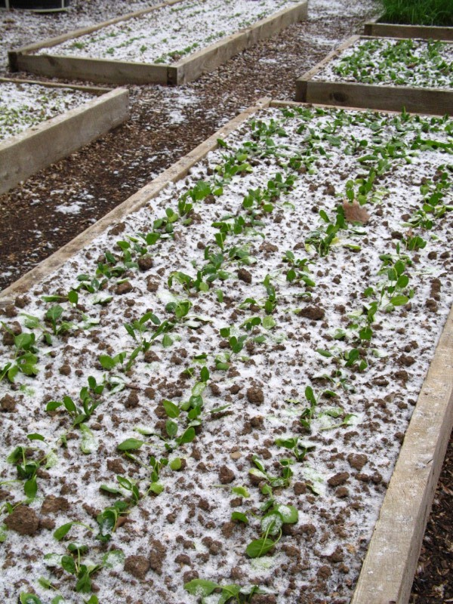

*Spinach in the Snow at the Frick Kitchen Garden*