

**Cooking Corner: Green Garlic**

Garlic is a fun and rewarding crop to grow at home. Plant it in the cool days of late fall, when the garden is otherwise barren. Soon after it is planted, garlic sprouts and pokes its thick green leaves through the soil. But these new leaves are hardy; the plant stops actively growing and waits in a period of dormancy through the cold winter. In the warmer days of spring, it grows quickly. It’s one of the first plants to add some much-missed bright green to the landscape!

Gardeners usually harvest garlic in early summer – often around the fourth of July. By this time many of its leaves have turned brown, and the heads of garlic have developed papers around each clove. Through this process of browning and drying out, the garlic is developing the ability to be stored. Once it’s harvested, after a couple of weeks of further drying, the garlic heads can be cut from the stem and stored in a cool, dark location for up to several months.

*Green garlic* is not a crop variety, it is simply garlic harvested early. Green garlic has been growing long enough to develop tasty garlic flavor but is still slender and long like a scallion. The cloves have not yet had a chance to form. Green garlic tastes like cloves of garlic, but it is tender and fresh. You can use any part of the plant – white or green, as long as it isn’t too tough to eat.

To plant green garlic, plan to plant extra in the fall. Some gardeners plant their garlic cloves extra close together (every 2-3”) in the fall, planning to thin the garlic by pulling every other plant out in the spring to use as green garlic. Or, if garlic cloves from your pantry start to sprout, plant them! You can do this in the ground or in a container, during the growing season. In the winter, try growing some in a pot on a sunny windowsill.

Green garlic can be hard to find in the grocery store but many local farmers offer this spring treat. Look for it at the farmers market this spring!

***A few tasty recipe ideas:***

[Spinach Green Garlic Soup](http://orangette.blogspot.com/2008/04/that-easy.html)

[Carmelized Green Garlic](http://articles.chicagotribune.com/2012-05-06/features/sc-food-0504-eskin-green-garlic-20120506_1_green-garlic-green-garlic-cloves)

[Spaghetti with Green Garlic](http://www.seriouseats.com/recipes/2012/06/alice-waters-spaghetti-with-green-garlic.html)

[Pickled Green Garlic](http://www.marthastewart.com/356924/pickled-green-garlic)

[Romaine Salad with Cilantro Green Garlic Vinaigrette](http://www.kitchenkonfidence.com/chopped-romaine-with-pickled-vegetables-toasted-pine-nuts-and-cilantro-green-garlic-vinaigrette/)

*Please see the photos on the following page.*

**[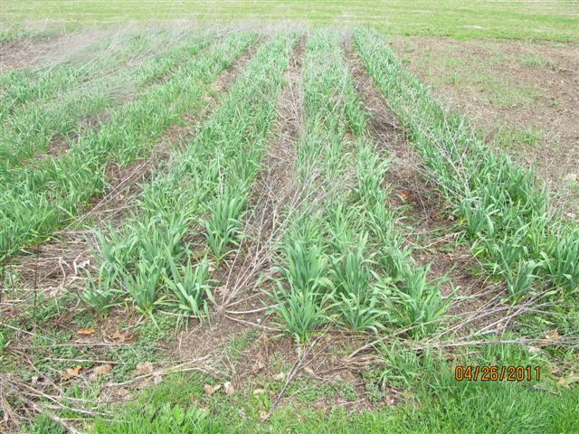](http://www.growpittsburgh.org/start-a-garden/resource-locator/the-urban-harvester/green-garlic-in-the-field-clubhouse-gardens/)**

Green garlic in the field at Clubhouse Gardens, another Penn's Corner Farm Alliance member farm. Thanks to Bill Foulk for the photo!

**[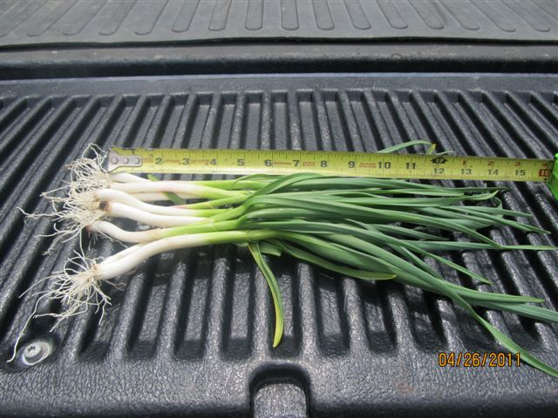](http://www.growpittsburgh.org/start-a-garden/resource-locator/the-urban-harvester/green-garlic-on-truckbed-clubhouse-gardens/)**

Just-harvested green garlic. Photo courtesy of PCFA member farmer Bill Foulk, of Clubhouse Gardens.